Sales Analysis

INTRODUCTION:
This project analysis sales performance using Power BI. The dataset includes order details, transaction amounts, customer geographical information, and target metrics across three primary source files: List of Orders, Order Details, and Sales target.
1. Data Sources
- List of Orders.csv: Contains general order, order dates, customer names, and geographical details.
- Order Details.csv: Contains line-item transaction data, sales amounts, profit metrics, product categories, and sub-categories.
- Sales target.csv: Contains category-level target sales benchmarks.
2. Data Transformation Steps
- Row Restriction & Type Conversion:
  - Restricted the List of Orders table to the first 500 rows.
  - Standardized column data types: Order Date set to Date, and Amount and Target set to Fixed Decimal Number.
- Text Formatting & Custom Columns:
  - Customer Name: Formatted into proper case (capitalized each word).
  - Location: Merged City and State columns into a combined string format (City, State).
  - Profit Margin: Created a custom column calculating profit percentage.
  - Profit Status: Added a conditional column classifying outcomes:
    - Loss if Profit < 0
    - Break-Even if Profit = 0
    - Profit if Profit > 0
- Table Merging & Aggregations:
  - Merged List of Orders and Order Details on Order ID to create a consolidated table named Orders Data.
  - Handled missing and duplicate values across datasets.
  - Aggregated duplicated reference tables to calculate order counts, average category profits, total sub-category amounts, and target amounts by month.

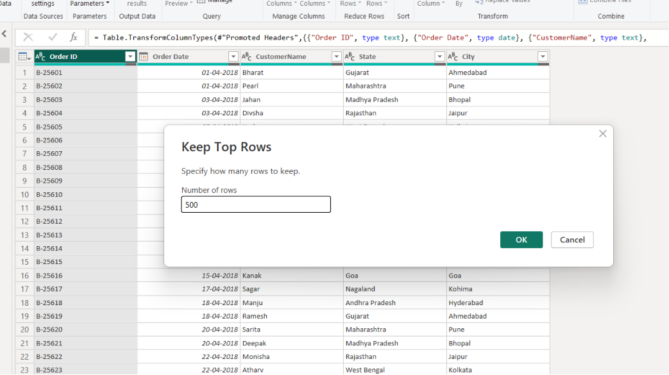
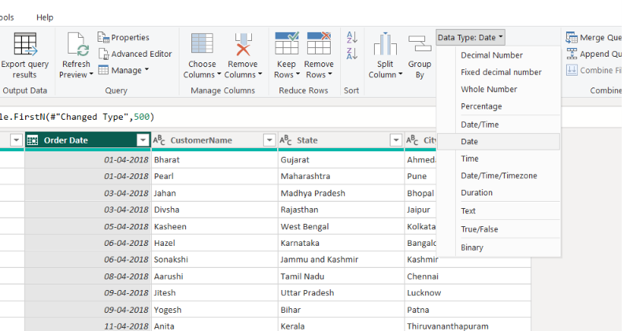
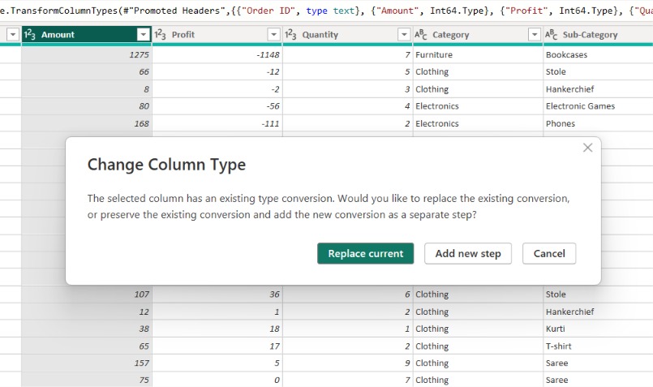

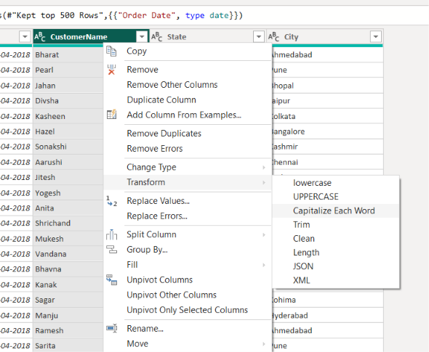
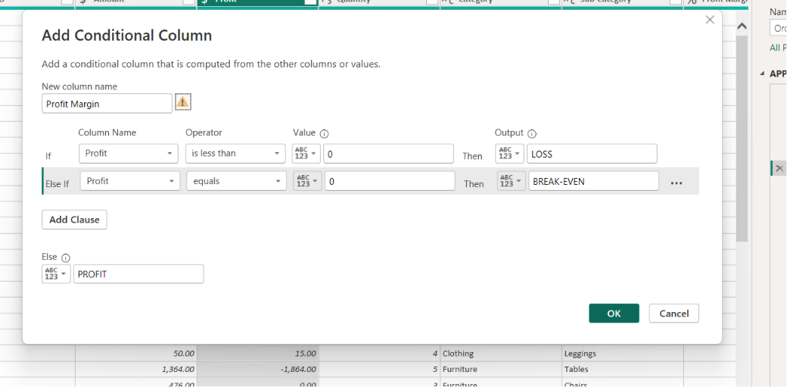
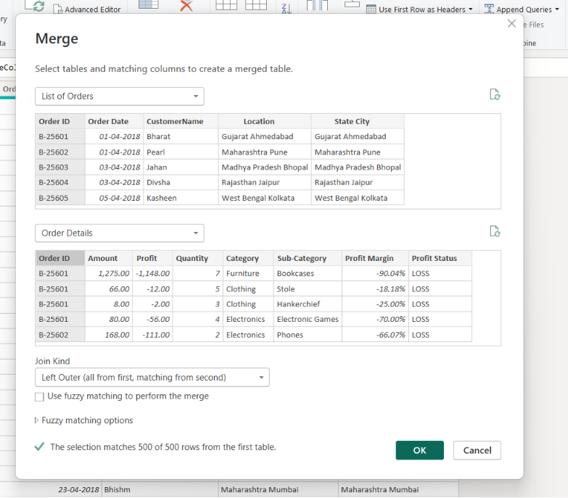
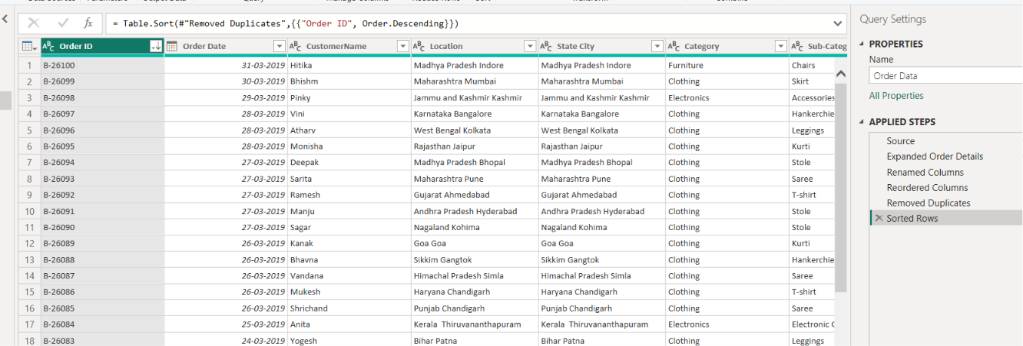

3. Data Modeling & Relationships
- Relationships Established:
  - List of Orders $↔$Order Details: Linked via Order ID.
  - Order Details $↔$Sales Target: Linked via Category.
- Managed relationships within Power BI Data Model view to ensure accurate cross-filtering and active context across visuals.
4. Key Analysis Capabilities
- Regional Insights: Filtered analysis capability by region (e.g., Tamil Nadu).
- Trend Analysis: Sorted by Order Date descending to track current performance trends.
- Performance Tracking: Evaluated actual profitability and category-level sales against established target thresholds.
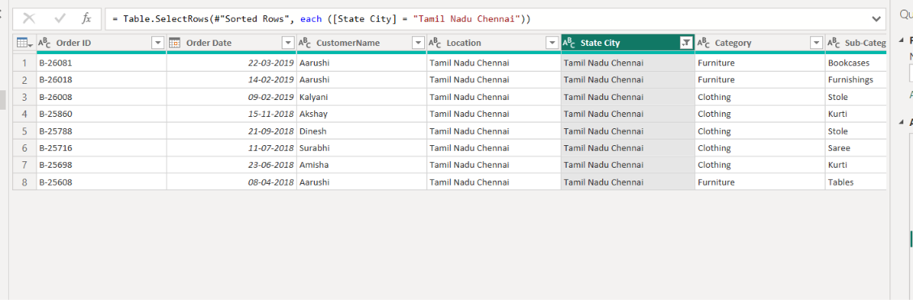
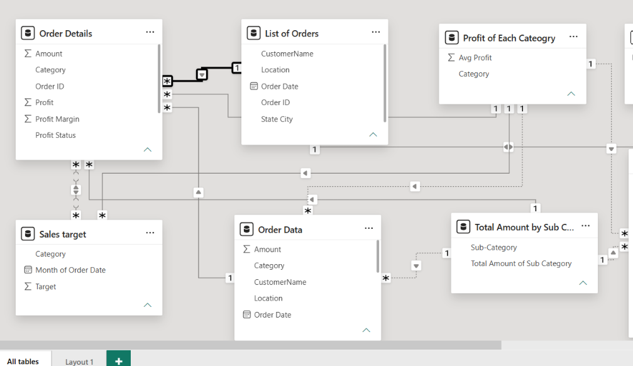
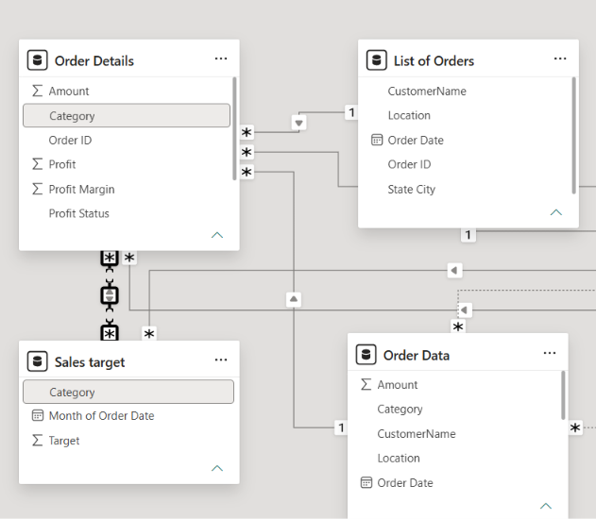

CONCLUSION:
This Power BI project successfully transformed raw data into an actionable analytics model. By cleaning and structuring order details, customer locations, and target metrics, the data was consolidated into a cohesive model capable of tracking real-time sales performance.

